"Now, we've got to make some changes in this country. The changes we have to have in this country are going to be for the liberation of all people—because nobody's free until everybody's free."

—Fannie Lou Hamer

Fannie Lou Hamer and the Struggle for Voting Rights and Economic Justice

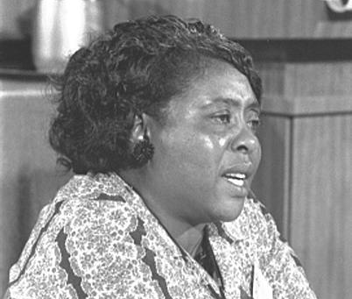 | In this lesson, we will explore the story of Fannie Lou Hamer, from her birth on a cotton plantation in the Mississippi Delta, to her role on the national stage in the struggle to gain political voice for African Americans, and to her later role as an activist for economic justice back home in Mississippi.

STEP 1: Hook (5 minutes)
Ask your students to watch the two-minute video “This Little Light of Mine: The Legacy of Fannie Lou Hamer”—trailer

- Individual Reflection—Ask students: What do you think Fannie Lou Hamer meant when she said “I question America!”?
- Create a “word splash”—Ask students: What is one word you might use to describe Mrs. Hamer?

Step 2: Profile of Fannie Lou Hamer (20 minutes)
From poverty-stricken beginnings in the Mississippi Delta, Fannie Lou Townsend Hamer rose to become one of the most prominent, committed, and influential leaders of the civil and voting rights movements, and a pioneer in African Americans’ efforts for greater access to voting rights and political opportunity.

In 1964, Hamer helped organize the famous Freedom Summer, when hundreds of Black and white college students from other parts of the country came to assist with registering African American voters in the segregated South.

- Read a Profile of Fannie Lou Hamer from the National Women’s History Museum.
- View video (27 minutes) from “Fannie Lou Hamer: Stand Up”
- Ask students to use an “I See/Notice, I Think, I Wonder” graphic organizer to note their thoughts as they read and watch the profiles of Fannie Lou Hamer.

Demanding A Seat at the Table
Hamer’s national recognition rose in 1964 when she co-founded the Mississippi Freedom Democratic Party, which opposed attempts by the Mississippi Democratic Party to suppress Black participation in voting and politics. Hamer and other leaders of the MFDP went to the Democratic National Convention, claiming that they should be accepted as the official delegation. The effort failed, but her impassioned speech, with its descriptions of racial prejudice in the South, had a great impact. Four years later, at the following Democratic National Convention, Hamer was a member of Mississippi’s first integrated delegation.

Video (four minutes): Fannie Lou Hamer's Powerful Testimony Before the 1964 Democratic National Convention

Step 3: Questions for Discussion (15 minutes)
- In what ways does an activist for social justice have to be fearless?
- How did Hamer’s struggle for voting rights connect with the idea that “nobody’s free until everybody’s free”?
- How can Fannie Lou Hamer’s personal example strengthen activists who face opposition and disappointment?

Step 4: What Can Students Do?
Use this step to expand on the legacy of Fannie Lou Hamer and her fight for voting rights. Divide the class into teams. Each team is assigned to conduct an interview based on the idea of “voting rights.”

Your interview subject may be an individual or organization that advocates for voting rights, and has participated in calling for the widest possible enfranchisement—for youth, or for minority communities, or for older people, or for those who are depending on postal access to the ballot box during the pandemic.

Using what your students learn, they will next assemble as a project team. Examples would include a theater piece, podcast, mural, poster display, comic strip or poem.

Here are two options for your students to join in with students from around the country working on similar projects:

RFK Human Rights Video Contest

RFK Human Rights Music Composition Contest

Additional Resources and Materials
Video (51 minutes): Library of Congress Broadcast 2017, “This Little Light of Mine”

Oral History interviews with Fannie Lou Hamer held in the University of Southern Mississippi Oral History Collection

Book Review: The Enduring Light of Fannie Lou Hamer

